**MOBILE APPLICATION DEVELOPMENT**

**(MAD)**

Name : Sourjadip Pramanik

Div: R

Roll_No : 53

ASSIGNMENT NO.2

# Assignment Name : Develop an application that uses GUI components, Font and Colors ( font size and color).

# I have created a multiscreen application in this assignment (3 screens) : So the code for each screen Activity is given below :

**Activity 1 : For the main page of the app.**

**Activity 2 : After clicking change font size button a new screen will appear.**

**Activity 3 : After clicking change color button a new screen will appear.**

Code for Manifest file :

<?*xml version*="1.0" *encoding*="utf-8"?>

<manifest *xmlns:android*="http://schemas.android.com/apk/res/android"

*package*="com.example.gui_app">

<application

*android:allowBackup*="true"

*android:icon*="@mipmap/ic_launcher"

*android:label*="@string/app_name"

*android:roundIcon*="@mipmap/ic_launcher_round"

*android:supportsRtl*="true"

*android:theme*="@style/Theme.Gui_App">

<activity *android:name*=".Color_change" />

<activity *android:name*=".Size_change" />

<activity *android:name*=".MainActivity">

<intent-filter>

<action *android:name*="android.intent.action.MAIN" />

<category *android:name*="android.intent.category.LAUNCHER" />

</intent-filter>

</activity>

</application>

Code for Xml file (Activity 1 ) ( activity_main.xml)

<?*xml version*="1.0" *encoding*="utf-8"?>

<LinearLayout *xmlns:android*="http://schemas.android.com/apk/res/android"

*xmlns:app*="http://schemas.android.com/apk/res-auto"

*android:layout_width*="match_parent"

*android:layout_height*="match_parent"

*android:id*="@+id/rView"

*android:background*="#99A4E3"

*android:orientation*="vertical">

<TextView

*android:id*="@+id/textView"

*android:layout_width*="match_parent"

*android:layout_height*="wrap_content"

*android:layout_margin*="50dp"

*android:gravity*="center"

*android:text*="@string/hello_world"

*android:textSize*="40sp"

*android:textStyle*="bold" />

<Button

*android:id*="@+id/button1"

*android:layout_width*="match_parent"

*android:layout_height*="wrap_content"

*android:layout_margin*="30dp"

*android:background*="#000000"

*android:gravity*="center"

*android:hapticFeedbackEnabled*="true"

*android:text*="@string/change_font_size"

*android:textSize*="20sp"

*android:textStyle*="bold"

*app:backgroundTint*="#C6A540" />

<Button

*android:id*="@+id/button2"

*android:layout_width*="match_parent"

*android:layout_height*="wrap_content"

*android:layout_margin*="30dp"

*android:gravity*="center"

*android:hapticFeedbackEnabled*="true"

*android:text*="@string/change_color"

*android:textColor*="#FF9100"

*android:textSize*="20sp"

*android:textStyle*="italic"

*app:backgroundTint*="#872323" />

<Button

*android:id*="@+id/button3"

*android:layout_width*="352dp"

*android:layout_height*="wrap_content"

*android:layout_gravity*="center"

*android:fontFamily*="monospace"

*android:gravity*="center"

*android:text*="@string/change_background_color"

*android:textColor*="#200353"

*android:textSize*="20sp"

*app:backgroundTint*="#D85D36" />

<Button

*android:id*="@+id/button4"

*android:layout_width*="wrap_content"

*android:layout_height*="wrap_content"

*android:layout_margin*="25dp"

*android:background*="@color/white"

*android:text*="@string/exit"

*android:textColor*="@color/black"

*app:backgroundTint*="#FF0000"

*app:iconGravity*="textTop"

*app:iconTint*="#FF0000"

*app:iconTintMode*="src_over" />

</LinearLayout>

Code for JAVA File (Activity 1 ) ( MainActivity.java)

*package* com.example.gui_app;

*import* android.content.Intent;

*import* android.graphics.Color;

*import* android.os.Bundle;

*import* android.view.View;

*import* android.widget.Button;

*import* androidx.appcompat.app.AppCompatActivity;

*import* java.util.Random;

*public class* MainActivity *extends* AppCompatActivity

{

View screenView;

Button background;

*int*[] color;

@Override

*protected void* onCreate(Bundle savedInstanceState)

{

*super*.onCreate(savedInstanceState);

setContentView(R.layout.*activity_main*);

color=*new int*[]{Color.*BLUE*,Color.*GREEN*,Color.*YELLOW*,Color.*CYAN*,Color.*MAGENTA*,Color.*GRAY*,Color.*RED*};

screenView= findViewById(R.id.*rView*);

background= (Button) findViewById(R.id.*button3*);

background.setOnClickListener(v -> {

*int* aryLength = color.length;

Random random = *new* Random();

*int* cNum = random.nextInt(aryLength);

screenView.setBackgroundColor(color[cNum]);

});

Button button1 = findViewById(R.id.*button1*);

button1.setOnClickListener(v -> openChange_size());

Button button2 = findViewById(R.id.*button2*);

button2.setOnClickListener(v -> openChange_color());

Button b4= findViewById(R.id.*button4*);

b4.setOnClickListener(v -> finish());

}

*public void* openChange_size() {

Intent intent = *new* Intent(*this*,Size_change.*class*);

startActivity(intent);

}

*public void* openChange_color() {

Intent intent = *new* Intent(*this*,Color_change.*class*);

startActivity(intent);

}

}

Code for XML File  **(Activity 2)**  (activity_size_change.xml)

<?*xml version*="1.0" *encoding*="utf-8"?>

<LinearLayout *xmlns:android*="http://schemas.android.com/apk/res/android"

*xmlns:app*="http://schemas.android.com/apk/res-auto"

*android:layout_width*="match_parent"

*android:layout_height*="match_parent"

*android:background*="#8261BD"

*android:orientation*="vertical">

<TextView

*android:id*="@+id/textView"

*android:layout_width*="match_parent"

*android:layout_height*="wrap_content"

*android:layout_margin*="50dp"

*android:gravity*="center"

*android:text*="@string/hello_world"

*android:textSize*="40sp"

*android:textStyle*="bold" />

<Button

*android:id*="@+id/button5"

*android:layout_width*="match_parent"

*android:layout_height*="wrap_content"

*android:layout_margin*="30dp"

*android:background*="#000000"

*android:fontFamily*="casual"

*android:gravity*="center"

*android:hapticFeedbackEnabled*="true"

*android:text*="@string/increase"

*android:textSize*="20sp"

*android:textStyle*="bold"

*app:backgroundTint*="#E91E63" />

<Button

*android:id*="@+id/button6"

*android:layout_width*="match_parent"

*android:layout_height*="wrap_content"

*android:layout_margin*="30dp"

*android:background*="#000000"

*android:fontFamily*="casual"

*android:gravity*="center"

*android:hapticFeedbackEnabled*="true"

*android:text*="@string/decrease"

*android:textColor*="#1C140A"

*android:textSize*="20sp"

*android:textStyle*="bold"

*app:backgroundTint*="#E3574C" />

<Button

*android:id*="@+id/button7"

*android:layout_width*="wrap_content"

*android:layout_height*="wrap_content"

*android:layout_gravity*="center|center_vertical"

*android:gravity*="center_horizontal|center_vertical"

*android:insetTop*="0dp"

*android:insetBottom*="0dp"

*android:text*="@string/back2"

*android:textSize*="16sp"

*app:backgroundTint*="#D34848"

*app:elevation*="0dp" />

</LinearLayout>

Code for JAVA File  **(Activity 2)**  (Size_change.java)

*package* com.example.gui_app;

*import* android.os.Bundle;

*import* android.widget.Button;

*import* android.widget.TextView;

*import* android.widget.Toast;

*import* androidx.appcompat.app.AppCompatActivity;

*public class* Size_change *extends* AppCompatActivity

{

*float* font1=40;

@Override

*protected void* onCreate(Bundle savedInstanceState)

{

*super*.onCreate(savedInstanceState);

setContentView(R.layout.*activity_size_change*);

*final* TextView t= findViewById(R.id.*textView*);

Button b5= findViewById(R.id.*button5*);

b5.setOnClickListener(v ->{

t.setTextSize(font1+5);

font1 = font1 + 5;

*if* (font1 == 90) {

font1 = 40;

Toast.*makeText*(getApplicationContext(), "Text font size cannot be increased further", Toast.*LENGTH_LONG*).show();

}

});

Button b6= findViewById(R.id.*button6*);

b6.setOnClickListener(v -> {

t.setTextSize(font1-5);

font1 = font1 - 5;

*if* (font1 == 20) {

font1 = 40;

Toast.*makeText*(getApplicationContext(), "Text font size cannot be decreased further", Toast.*LENGTH_LONG*).show();

}

});

Button b7= findViewById(R.id.*button7*);

b7.setOnClickListener(v -> finish());

}

}

Code for XML File  **(Activity 3)**  (activity_color_change.xml)

<?*xml version*="1.0" *encoding*="utf-8"?>

<LinearLayout *xmlns:android*="http://schemas.android.com/apk/res/android"

*xmlns:app*="http://schemas.android.com/apk/res-auto"

*xmlns:tools*="http://schemas.android.com/tools"

*android:layout_width*="match_parent"

*android:layout_height*="match_parent"

*android:background*="#9CCCF3"

*android:orientation*="vertical">

<TextView

*android:id*="@+id/textView"

*android:layout_width*="match_parent"

*android:layout_height*="wrap_content"

*android:layout_margin*="50dp"

*android:gravity*="center"

*android:text*="@string/hello_world"

*android:textSize*="40sp"

*android:textStyle*="bold" />

<Button

*android:id*="@+id/button8"

*android:layout_width*="match_parent"

*android:layout_height*="wrap_content"

*android:fontFamily*="cursive"

*android:text*="@string/yellow"

*android:textColor*="#250404"

*android:textSize*="16sp"

*app:backgroundTint*="#EAD410"

*tools:ignore*="DuplicateIds" />

<Button

*android:id*="@+id/button9"

*android:layout_width*="match_parent"

*android:layout_height*="wrap_content"

*android:fontFamily*="casual"

*android:text*="@string/blue"

*android:textColor*="#050101"

*android:textSize*="16sp"

*android:textStyle*="bold"

*app:backgroundTint*="#556DF1" />

<Button

*android:id*="@+id/button10"

*android:layout_width*="match_parent"

*android:layout_height*="wrap_content"

*android:fontFamily*="serif"

*android:text*="@string/red"

*android:textColor*="#170402"

*android:textSize*="16sp"

*android:textStyle*="bold"

*app:backgroundTint*="#F44336" />

<Button

*android:id*="@+id/button11"

*android:layout_width*="match_parent"

*android:layout_height*="wrap_content"

*android:fontFamily*="casual"

*android:text*="@string/green"

*android:textAppearance*="@style/TextAppearance.AppCompat.Body1"

*android:textColor*="#022303"

*android:textSize*="16sp"

*android:textStyle*="bold"

*app:backgroundTint*="#4B7A15" />

<Button

*android:id*="@+id/button12"

*android:layout_width*="match_parent"

*android:layout_height*="wrap_content"

*android:fontFamily*="sans-serif-medium"

*android:text*="@string/gray"

*android:textColor*="#332828"

*android:textSize*="16sp"

*android:textStyle*="bold"

*app:backgroundTint*="#918383" />

<Button

*android:id*="@+id/button13"

*android:layout_width*="102dp"

*android:layout_height*="wrap_content"

*android:layout_gravity*="center|center_vertical"

*android:gravity*="center_horizontal|center_vertical"

*android:insetTop*="0dp"

*android:insetBottom*="0dp"

*android:text*="@string/back1"

*android:textSize*="16sp"

*app:backgroundTint*="#85099A"

*app:elevation*="0dp" />

</LinearLayout>

Code for JAVA File  **(Activity 3)**  (Color_change.java)

*package* com.example.gui_app;

*import* androidx.appcompat.app.AppCompatActivity;

*import* android.graphics.Color;

*import* android.os.Bundle;

*import* android.widget.Button;

*import* android.widget.TextView;

*public class* Color_change *extends* AppCompatActivity {

@Override

*protected void* onCreate(Bundle savedInstanceState) {

*super*.onCreate(savedInstanceState);

setContentView(R.layout.*activity_color_change*);

*final* TextView t = findViewById(R.id.*textView*);

Button b8 = findViewById(R.id.*button8*);

b8.setOnClickListener(v -> t.setTextColor(Color.*YELLOW*));

Button b9 = findViewById(R.id.*button9*);

b9.setOnClickListener(v -> t.setTextColor(Color.*BLUE*));

Button b10 = findViewById(R.id.*button10*);

b10.setOnClickListener(v -> t.setTextColor(Color.*RED*));

Button b11 = findViewById(R.id.*button11*);

b11.setOnClickListener(v -> t.setTextColor(Color.*GREEN*));

Button b12 = findViewById(R.id.*button12*);

b12.setOnClickListener(v -> t.setTextColor(Color.*GRAY*));

Button b13 = findViewById(R.id.*button13*);

b13.setOnClickListener(v -> finish());

}

}

SCREENSHOTS OF APP

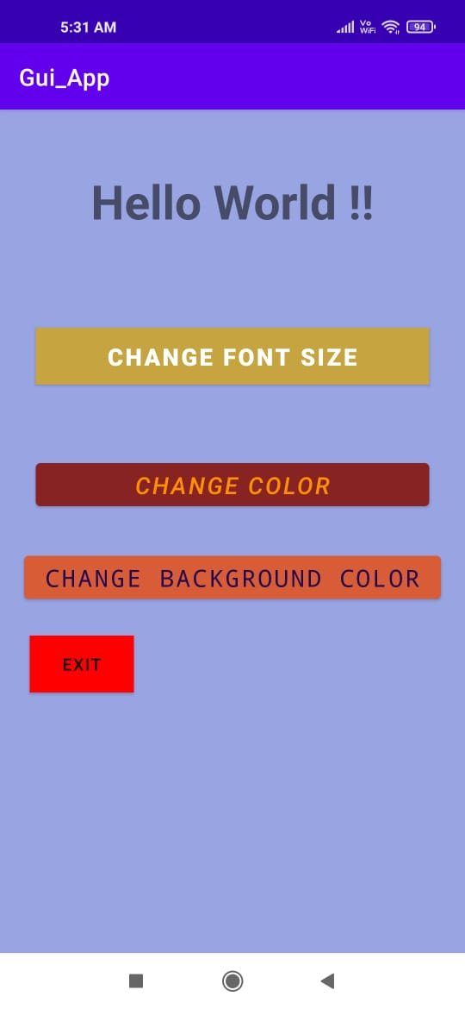

After clicking CHANGE FONT SIZE

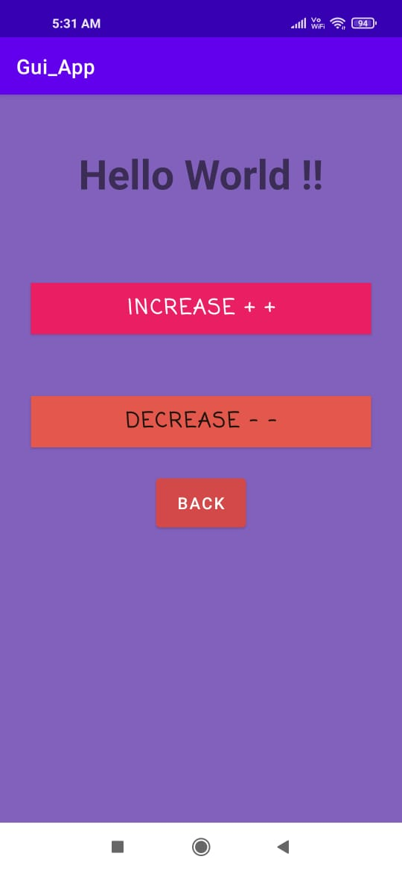

After **Clicking Increase** For Many times (10) a toast is created :

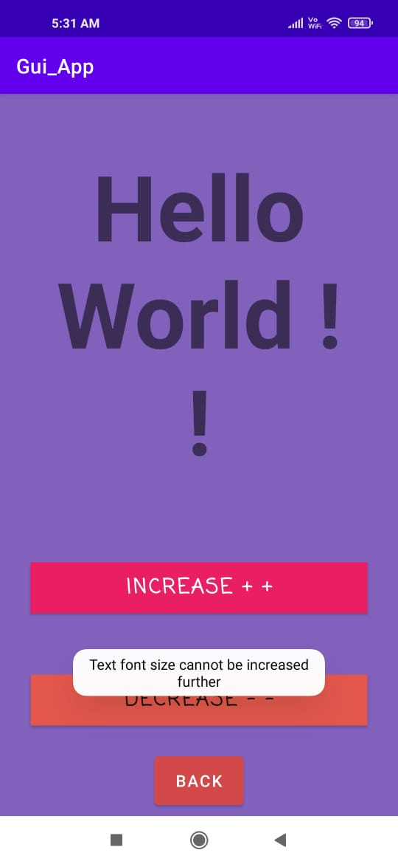

After **Clicking decrease** after a certain size a toast is created :

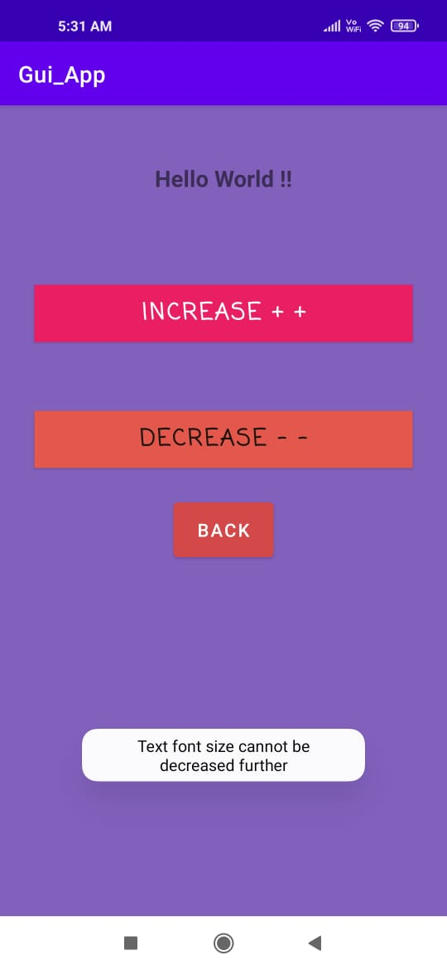

After Clicking back :

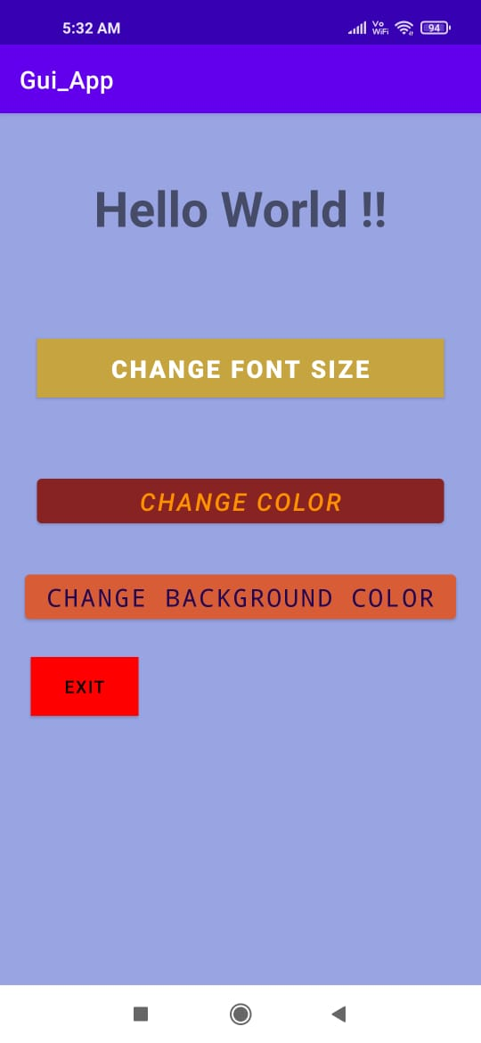

After clicking CHANGE COLOR :

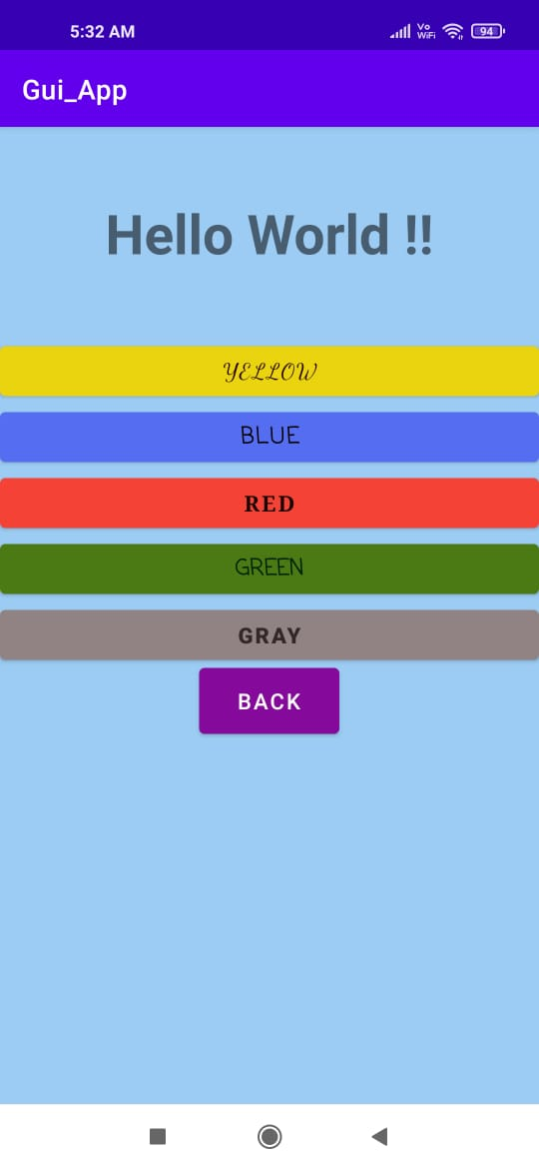

After Clicking RED

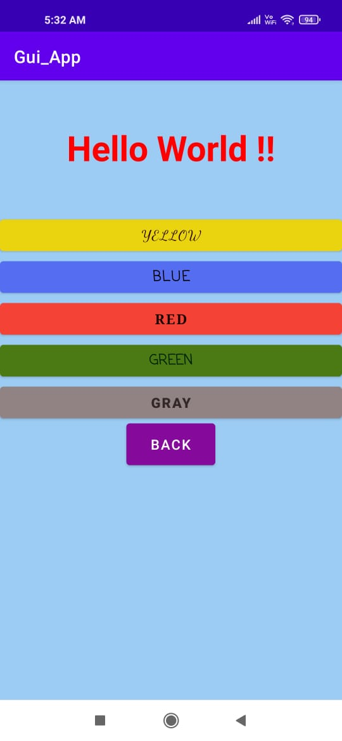

Then after clicking Back and CHANGE BACKGROUND COLOR

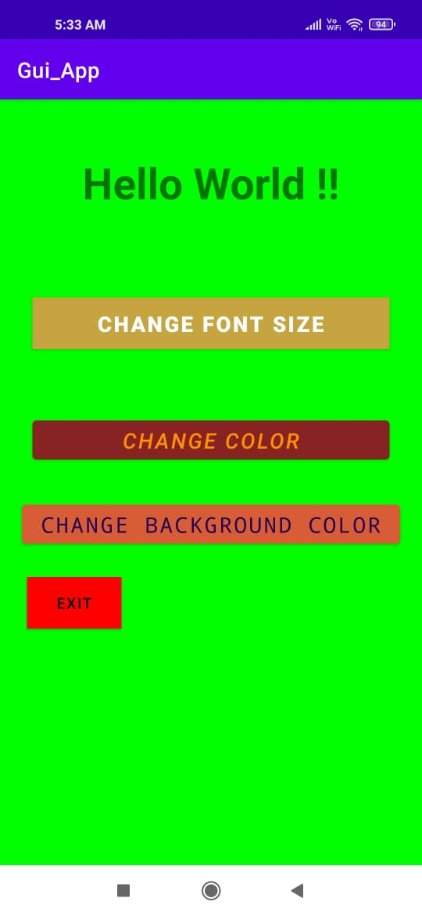I have created a array of colors for background so each time a random colour is selected.

Again clicking the CHANGE BACKGROUND COLOR button

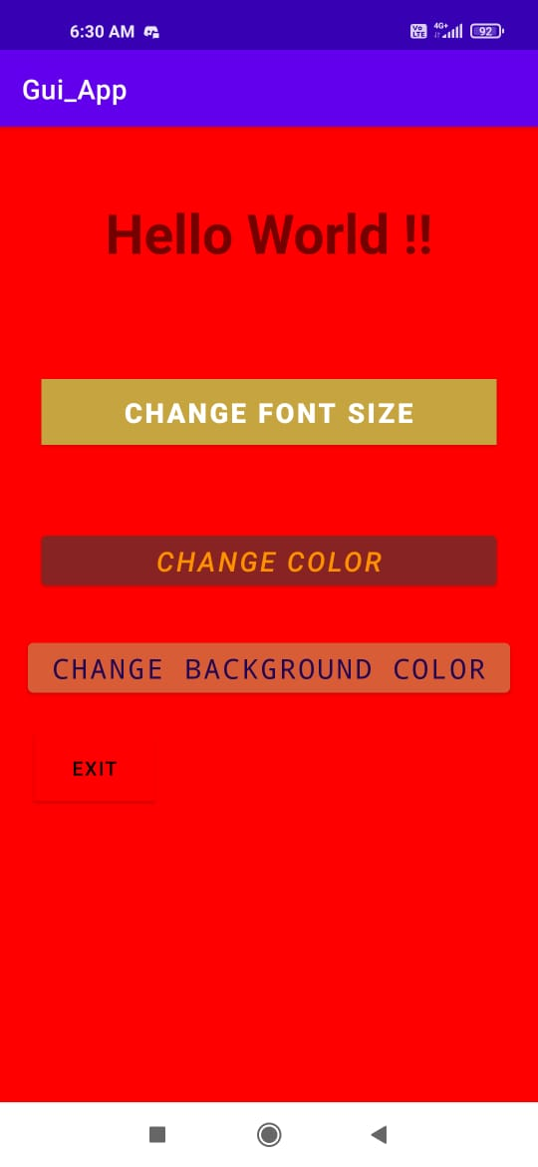

Again :

